**Lab Assignment-1**

**Create the following tables**

Course(course_no char(4), course_name varchar(20))

Course_fee(course_no char(4), full_part char(1) (F/P), fees number(10))

course_no and full_part should be unique

Student(prospectus_no number(10), name varchar(20), address varchar(30), phone_no number(11), D_O_B date, total_amt number(10,2), amt_paid number(10,2), installment char(1) (I/F))

Installment(prospectus_no number(10) (foreign key) on delete cascade, installment_amt number(10,2), due_dt date, paid char(1) (P,U))

prospectus_no and due_dt should be unique

Course_taken(prospectus_no number(10) (foreign key), course_no char(4), start_dt date, full_part char(1) (F/P), time_slot char(2), performance varchar(20))

**Queries and Outputs of the Table:**

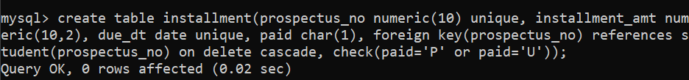

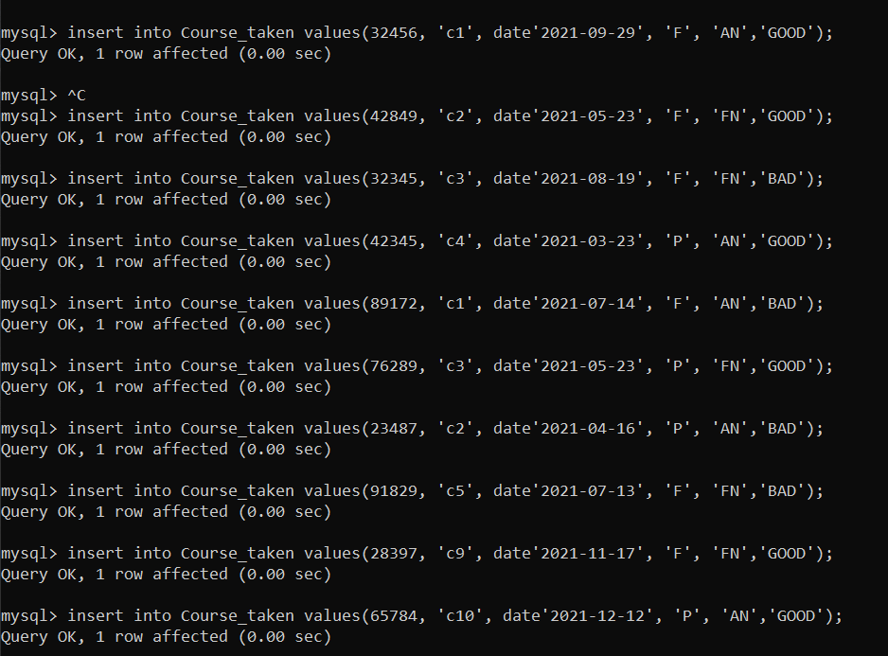

**SQL Queries:**

* 1. Retrieve name and course no of all the students.

* 1. List the names of students who have paid the full amount at the time of admission.

* 1. Find the names of students starting with A.

* 1. Print the names of students whose total amount is not equal to amount due.

* 1. Count the number of students who have joined in current year, current month.

* 1. Determine the maximum and minimum course fees.

* 1. Increase the fee of oracle by 50%.

* 1. Print the details of courses whose fees are between 5000 and 10000.

* 1. Display the admission date in Date, Month, Year format.

* 1. Find out in which course maximum number of students have taken admission.

* 1. Change the course_name from C to C Programming.

* 1. Display the admission date in DD-MONTH-YYYY format.

* 1. Get the sum of amount to be collected from students in this month.



* 1. Find out in which course the maximum number of students have taken admission in the current month.

* 1. Select the students who have not yet paid full amount of fees.

